1. Which of the following is a mistake from the given code? - **None of the above**

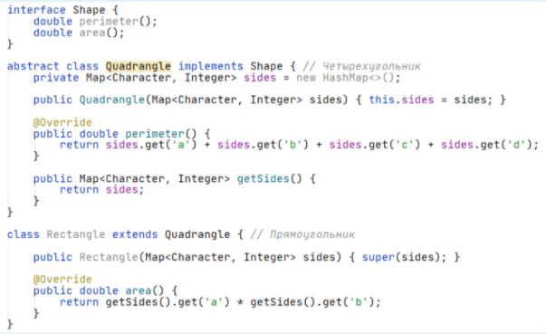

1. Say that there are three classes: Computer, AplleComputer, and IBMComputer. What are the likely relationships between these classes? - **Computer it the superclass, AplleComputer and IBMComputer are subclasses of Computer.**
2. Use picture above to answer the question. Which of the following lines will give errors? - **1, 7**

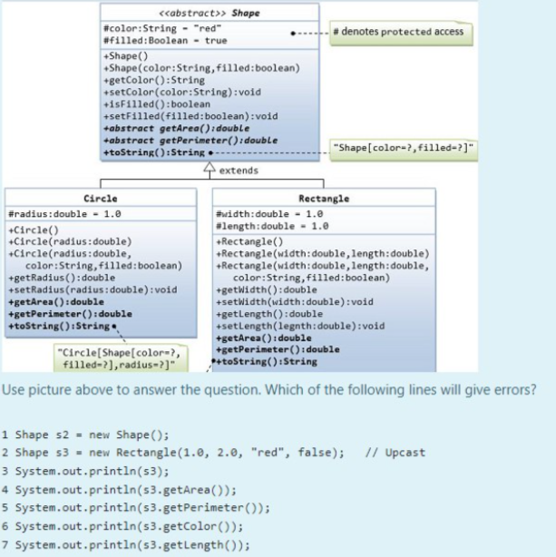

1. Which oops concept is used as reuse mechanism? - **Inheritance**
2. What will be the output of following program? - **No story With Story Good Movie**

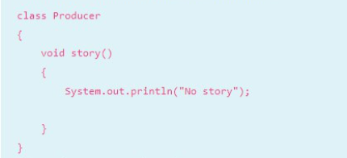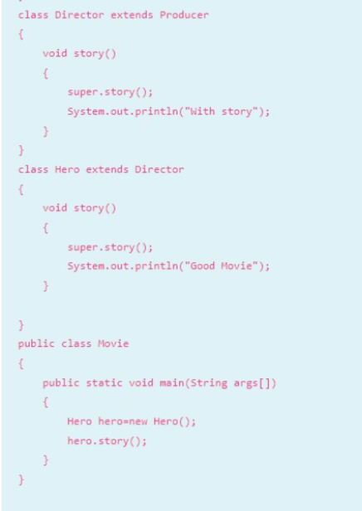

1. Encapsulation is used to control variable assignment? - **True**
2. It is a mechanism of wrapping the data and code acting on the data together as a single unit - **Encapsulation**
3. There is superclass Person which has method work(). Class Fighter extends class Person and has method fight(). Which of the following statements is false? - **Person can fight**
4. What is an object? - **It is an instance of class**
5. Inheritance is used when the relationship between two classes _____ - **is-a**
6. How many objects of a given class can there be in a program? - **As many as the program needs.**
7. When subclass has its own implementation, different from superclass version it is called _____ - **Method Overriding**
8. In other words encapsulation is: **Data hiding**
9. Which of the following is **True** in JAVA? - One class can implement more than one interface
10. Use picture above to answer the question. Which of the following lines will give errors? - **7**

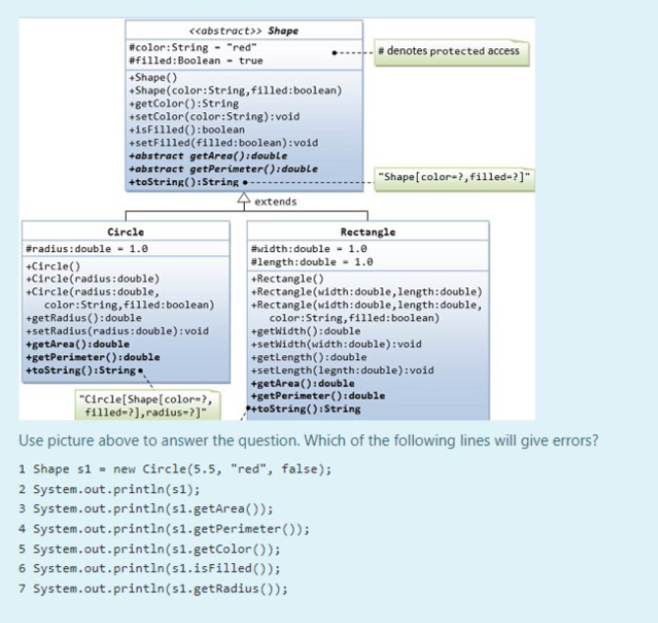

1. Which OOP principle enables you to deal in generalities and let the execution-time environment handle the specifics? - **Polymorphism**
2. Encapsulation is a mechanism of wrapping _____ and code acting on _____ together as a single unit. Fill the missing part. - **variables, methods**
3. What method is implemented in Cosmic Superclass? - **toString()**
4. Which of these is **NOT** an advantage of OOP? - **Less program size.**
5. What’s the extension for a compiled Java file? - .class
6. What is constructor in Java? - **Constructor is similar to a method but is called implicitly by the new operator to initialize an object's instance variables when the object is created**
7. Which of the following is false about encapsulation? - **In encapsulation the methods of the class will be hidden**
8. Use picture above to answer the question. Which of the following lines will give errors? - None

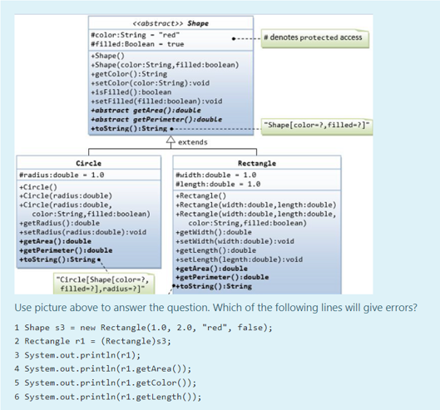

1. What do we call a simple function that is called using reference variable? - **Method**
2. Java supports only single inheritance, in which each class is derived from exactly one direct superclass. TRUE or FALSE? - **TRUE**
3. Which of these can be used only when an object of that class type has been created - **Non-static members**
4. When the subclass method is intended as a replacement of the superclass method. - (not aggregation)
5. What can be accessed by members of the superclass, of its subclasses and other classes in the same package? - superclass’s protected members
6. Which of these types is non-primitive? - **int[]**
7. What is the reason to use method overriding? - **It is used whenever subclass needs specific implementation of superclass method**
8. What is protected access modifier? - **It gives permission to access current member only from subclasses or from the same package**
9. Which of these is correct way of inheriting class A by class B? - **class B extends A {}**
10. What allows you to save time during program development by basing new classes on existing proven and debugged high-quality software? - **Inheritance**
11. If data members are private, what can we do to access them from the class object? - **Create public member functions to access those data members**
12. A class Animal has a subclass Mammal. Which of the following is true: **Mammal can have no other parent than Animal.**
13. Which OOPS concept means exposing only necessary information to the calling functions? - **Encapsulation**
14. Public static void main(String args[]) (which part of the code above responsible for method or variable not being an instance related but class related?) - **static**
15. One class could have only one constructor - **False**
16. Aggregation in Java is a relationship between two entities, where the composed object **cannot exist** without the other entity. - **False**
17. Which of these is a reference to the parent class object? - **super**
18. Which of this keyword must be used to inherit a class? - **extends**
19. What is the main difference of an interface from abstract class? - **An interface contains only abstract methods**
20. Which of the following statements is false? - **Static methods can be used only after object of the class type has been created**
21. In other words encapsulation is: **Data hiding**
22. Which of the following statements are true for inheritance in Java? - (not The “extend” keyword is used to extend a class in java.)
23. What is a composition? - **It is a relationship between objects where the composed object cannot exist without the other entity**
24. Which of the following is a mistake from the given code? - 

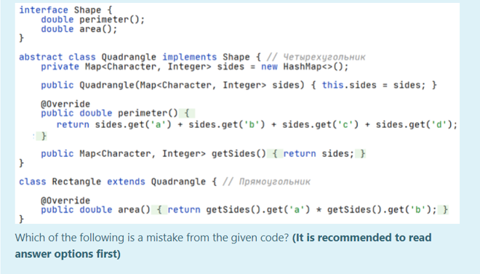

1. What is an aggregation? - **It is a relationship between objects, where both the entries can survive individually which means ending one entity will not effect the other entity**
2. In order to use encapsulation inside a class, method and variable must be: **variable-private , method-public**
3. What are the advantages of OOP? - **Reusability, Efficiency, Extensibility, Refactoring**
4. What kind of programming languages is Java? - **Object-Oriented Programming Language**
5. What is described in the following statement? - (not Data manipulation)



1. Which class is a class that inherits a method or methods from a superclass? - **Sub class**
2. What is FALSE about a constructor? - **A constructor is a public method of a class which can be explicitly called using a class object**
3. Which is correct syntax for creating an object of Class in Java? - classname objectname = new classname();
4. Which of these is NOT the idea behind an Encapsulation? - **It enables you to “program in the general” rather than “program in the specific”**
5. An inheritance is … **the mechanism by which one class is allowed to inherit the features (fields and methods) of another class.**
6. What are the relationships in the following sentences? A computer owns a CPU. A computer has a user. - **composition, aggregation**
7. Which of these is the main idea behind “Polymorphism”? - **it enables you to “program in the general” rather than “program in the specific”**
8. What is **TRUE** about objects’ association? - **Aggregation is when objects are using “has-a” relationship, whereas, composition is when objects are using “is-part-of” relationship**
9. A public method that reads and returns data from one or more private instance variables - **Accessor method**
10. ___ method cannot be overridden by a subclass - **final**
11. What type of inheritance does Java have? - **single inheritance**
12. What is a direct superclass of monkey in the following scheme? animal - mammal - monkey - gorilla - **mammal**
13. What kind of constructors exist in Java? - **No argument and parameterized constructors**
14. What is called using this() - **Current class’s no-argument constructor**
15. What is **TRUE** about private member variables? - **Private member variables can be accessed indirectly using their accessors and mutators**
16. What is FALSE about casting in Java? - **One subclass reference can be casted to absolutely another subclass reference of the same direct superclass**
17. What is called using super() - **Super class’s no-argument constructor**
18. Which class is called as “Cosmic superclass” - **Object**
19. Call to super() must be first statement in subclass constructor. What will happen if you don’t call it explicitly? - **the compiler would attempt to insert a call to the superclass’s default constructor**
20. What do we use to define the behavior of an object? - **Method**
21. Which of the following can be static? - **Class**
22. Java is a/an - **Object-oriented language**
23. Which of these access specifiers must be used for main() method? - **public**
24. Which of the following is not the name of a Java primitive data type? - **String**
25. What is the return type of a method that does not return any value? - **void**
26. Which of these class in superclass of every class in Java? - **Object class**
27. A class can have only one constructor - **False**
28. Which of the following is an incorrect statement about packages? - **A package can be renamed without renaming the directory in which the classes are stored**
29. Public static void main(String args[]) (which part of the code above responsible for method being taken as a starting point of an application by JVM?) - **main**
30. What is the incorrect statement about static identifier? - **static fields and methods need an object creation**
31. Which of this access specifies can be used for a class so that its members can be accessed by a different class in the same package? - **All of the mentioned**
32. What do we use to define the state of an object? - **Field**
33. Non-static fields and methods cannot be called from static methods - **True**
34. What is the incorrect statement about primitive data types? - **Primitive data types can not be directly used in any program. We have to create a user-defined data type and then use it.**
35. Which of these keywords is used to make a class? - **Class**
36. A private member of a class is visible to: **members of same class**
37. Non-static fields and methods can be called from static methods - **False**
38. Say that a particular item of data does not use a primitive data type. What must it be? - **An object**
39. public static void main(String args[]) (which part of the code above responsible for method being accessible by any class?) - **public**
40. Which of the following statements is correct? - **Public method is accessible to all other classes in the hierarchy**
41. Which method can be defined only once in a program? - **main method**
42. Constructor can return a value - **False**
43. When the subclass method is intended as a replacement of the superclass method – **overriding**
44. Which of the following is about Interface segregation principle? - **Many client-specific interfaces are better than one general-purpose interface.**
45. What can help to achieve multiple inheritance in Java? - **Interfaces**
46. What type of inheritance does Java have? - **single inheritance**
47. Which of the below is not a valid classification of design pattern - **Observer patterns**
48. Which of the following principles asks us to implement Is-A relationship carefully? - **liskov substitution principle**
49. Which of the following is about Liskov substitution principle? - **Objects in a program should be replaceable with instances of their subtypes without altering the correctness of that program.**
50. Choose correct type of polymorphism for: Method overloading Method overriding - **1. compile-time polymorphism and 2. runtime polymorphism**
51. What is the correct option to create a statement? - **Statement stmt = conn.create.Statement();**

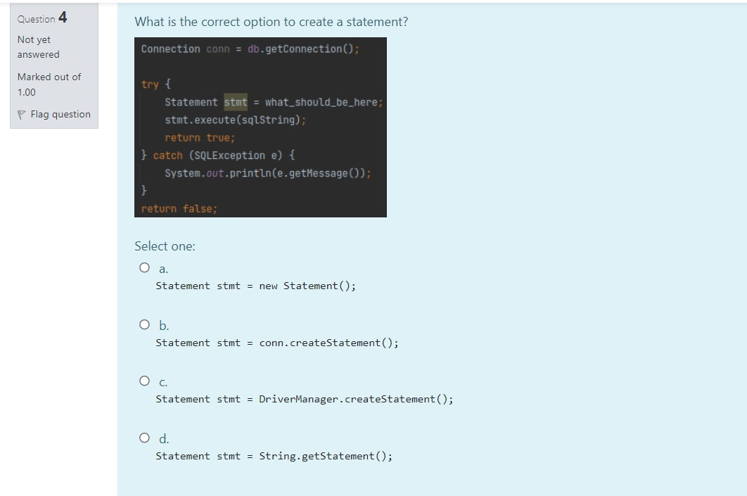

1. What the following statement is about? - **A.class shouldn’t be forced to implement undeeded methods of an interface**

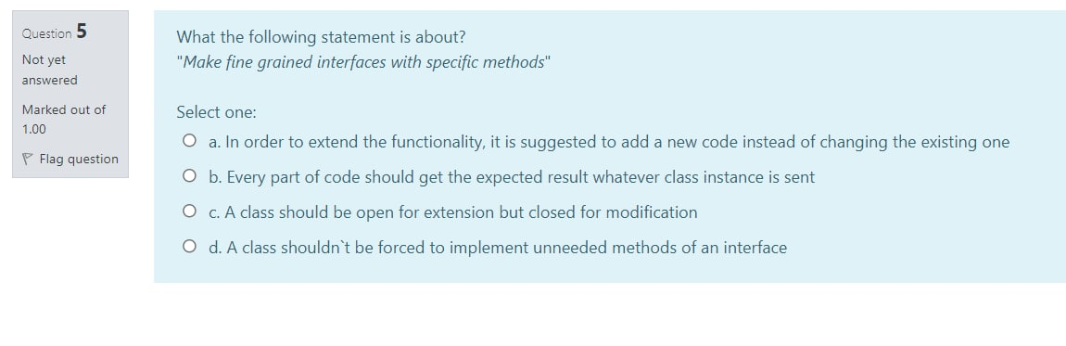

1. Which class is used to get the connection to database? -**DriverManager** 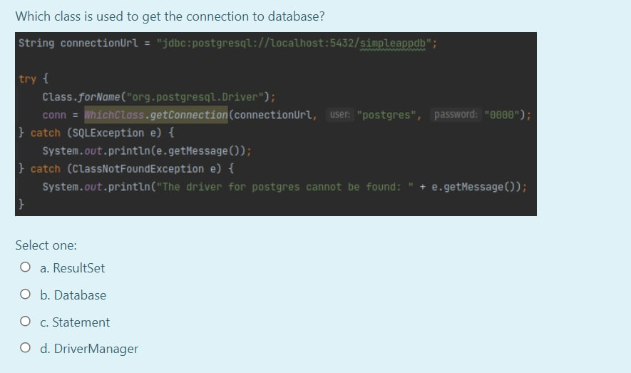
2. Which of the following is a mistake from the given code? - **Class Quadrangle should extend Shape instead of implementing is**

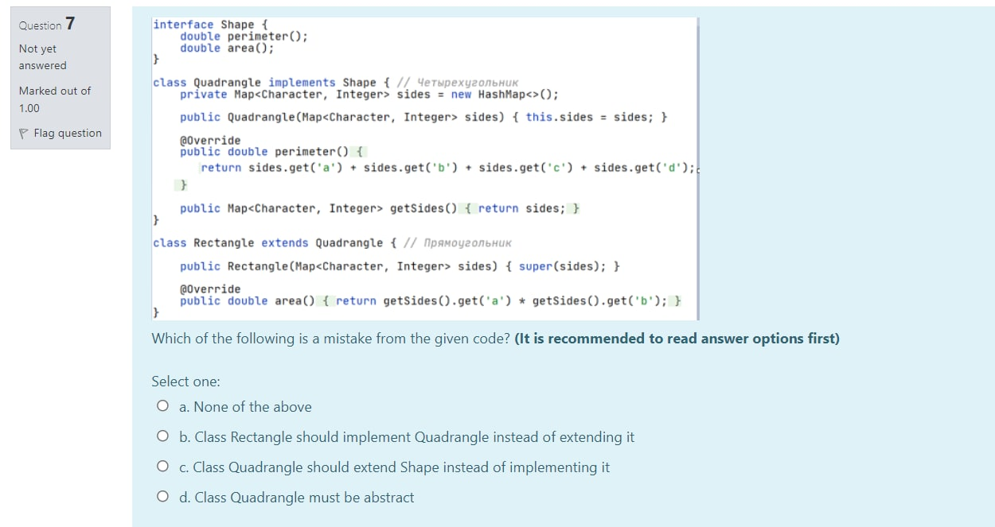

1. In order to handle exceptions in java we use: - **try{...}catch(...){...}**
2. Aggregation in Java is a relationship between two entities, where the composed object cannot exist without the other entity. - **False**
3. The built-in base in Java, which is used to handle all exceptions is - **throwable**
4. Which is the benefit of using interface instead of abstract class in Java? - **it is possible to implement several interfaces in one class**
5. Which of the following statement is about? - **In order to extend the functionality, it is suggested to add a new code instead of changing the existing one**

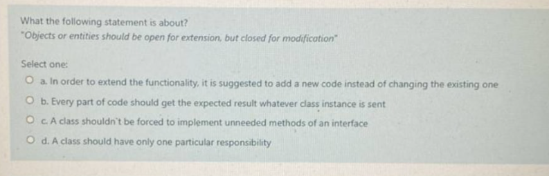

1. What the following statement is about? - **A class should have only one particular responsibility**

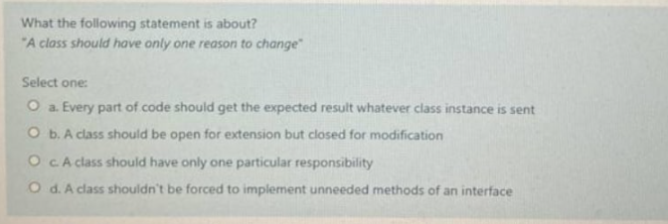

1. What does “S” in the SOLID stand for? - **single responsibility principle**
2. What is the main difference of abstract class from the concrete class? - **It is not allowed to instantiate an object using an abstract class**
3. Which of the following is about Single-responsibility principle? - **A class should only have a single responsibility…**
4. Which of the following is about Dependency inversion principle? - **Software entities ... should be open for extension, but closed for modification**
5. What is output of the following program if input is t 0? - **NumberFormatException!** 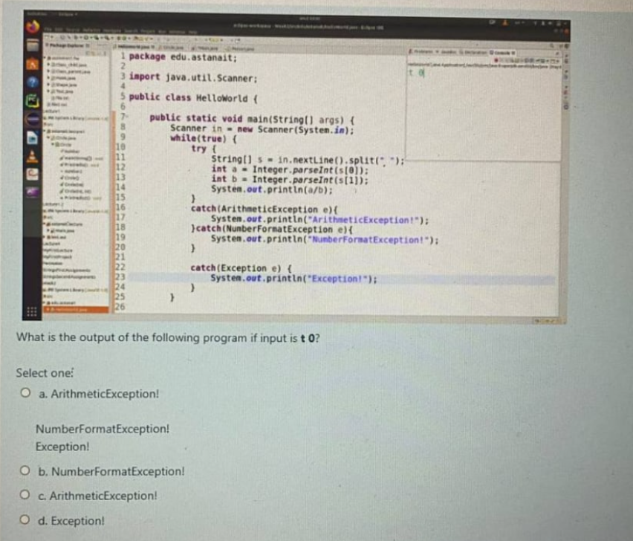
6. Block **finally** in exception handling executes: - **Always**
7. To prevent any method from overriding, we declare the method as -**final**
8. Static fields and methods can be called from non-static methods - **True**
9. What is the reason to use try-catch block? - **For exception handling**
10. A constructor is a public method of a class which can be explicitly called using a class object - **Add abstract keyword in the declaration of this class**
11. Which of these is **FALSE** about static members? - **A memory for storing static members is allocated during the object creation**
12. What is the advantage of Encapsulation? - **All of the above**
13. Choose the correct structure for exception handling - **try{…} catch(exception){…}**
14. Find a definition of Casting in Java - **Casting is the process of converting one data type to another**
15. Which of these is a reference to the current object? - **this**
16. Which of the following should have the same name as that of it’s class? - **Constructor**
17. Which of the following is true about protected access modifier? - **Variables, methods and constructors which are declared protected can be accessed by any class lying in same package.**
18. Which of the following is a valid declaration of an object of class Dog? - **Dog dog= new dog()**
19. What operator is commonly used to differentiate object member variable from any other local variables? - **this**
20. Static fields and methods defined in a class can be used only when an object of that class type has been created - **False**
21. Static fields and methods defined in a class can be used only when an object of that class type has been created - **access Modifiers**
22. A class can have more than one constructor with different signature **-** **True**
23. Which of these is true statement about having static methods in interfaces? - (a. Static methods in interface are such methods which are called only using that interface directly b. An interface cannot have static methods, since it must consist of only abstract methods c. Static methods in interface are abstract, they can have their implementation only in a class that implements that interface d. Static methods in interface can be overridden in implementation class)
24. Which of the following is about Factory Method design pattern? - (a. A fully initialized instance to be copied or cloned b. Creates an instance of one of the several families of classes c. Creates an instance of one of the several derived classes d. Avoid expensive acquisition and release of resources by recycling objects that are no longer in use e. Separates object construction from its representation) e
25. What should a programmer do if the class partially implements the interface in JAVA? - (a. A programmer must provide full implementation of interface b. Add abstract keyword in the declaraion of this class c. Add final keyword in the declaraion of this class d. Add static keyword in the declaraion of this class) b
26. Which of these is an appropriate case for applying the builder pattern? - ( a. When the creation of an object involves third-party objects to react and apply some modification on their behavior b. When it is needed to have only one instance of the class throughout an application c. When the creation of an object is extremely complex, with lots of mandatory and optional parameters d. When the implementation of an interface or an abstract class is expected to change frequently) c
27. What is default method in interfaces? ( a. A method that can be implemented using the lambda expression b. A method that has final implementation, which cannot be overridden in implementation classes c. A method that has default generic type d. A method that has default implementation) d
28. Which of these is a disadvantage of Singleton pattern? (a. It is hard to make unit testing since its constructor is private and overriding static methods is mostly impossible b. There is an access restriction to the instance that Singleton class provides c. An instance of Singleton class is created twice for every request d. It becomes more expensive to obtain an instance of Singleton class) a
29. Which of the following is about Singleton design pattern? (a. Add responsibilities to objects dynamically b. A single class that represents an entire subsystem c. A class of which only a single instance can exist d. Separates an object's interface from its implementation e. An object representing another object) c
30. It is possible to send a lambda expression to some method as a parameter (True False)
31. Define a family of algorithms, encapsulate each one, and make them interchangeable. It lets the algorithm vary independently from clients that use it - **Strategy**
32. What is the benefit of using interface instead of abstract class in JAVA ( a. it is possible to create more than one constructors in interface b. interface can define the default state of an object c. Interface can instantiate an object, whereas abstract class cannot d. it is possible to implement several interfaces in one class)
33. Which class is called as "Cosmic superclass" ( a. Parent class b. Neibourgh class c. Object d. Sub class)
34. According to creational design patterns, which operator is considered to be harmful as it scatters objects all over the application? - **new**
35. Generics represent an anonymous method - that is, a method without a name - **False**
36. SOLID term was introduces by - **Robert Martin**
37. What is Immobility? - **cannot reuse code outside of its original context**
38. What is SOLID? - **design patterns**
39. Which one(s) is true about Single Responsibility Principle? - **A class should have only one reason to change, Class should have only one job**
40. What is Rigidity? - **every change affects many other parts**
41. Static Methods in Interface are those methods, which are defined in the interface with the keyword static - **True**
42. Which one(s) is true about Open/Closed Principle? - **Extend functionality by adding new … , Objects or entities should be open for …**
43. Which one(s) is true about the Reuse/Release Equivalence Principle - **Classes and modules that are formed into…, The granule of reuse is the …**
44. Which one(s) is true about the Dependency Inversion Principle? - **It states that the high-level module must not depend on the low-level module…, Depend on abstractions, not on…**
45. Which one(s) is true about Common Reuse Principle? - **Classes and modules that tend to be reused…, A dependency upon package is a dependency upon…**
46. Which one(s) is true about Interface Segregation Principle? - **Clients shouldn’t be forced to depend…, A client should never be forced…, A client should never depend…**
47. Which one(s) is true about the Common Closure Principle? - (• Gather into components those classes that change for the same reasons and at the same times, • Separate into different components those classes that change at different times and for different reasons, • The more packages that change in any given release, the greater the work to rebuild, test, and deploy the release)
48. Which one(s) is true about Liskov Substitution Principle? - (• Every part of code should get the expected result whatever class instance is sent, • Let φ(x) be a property provable about objects of x of type T. Then φ(y) should be provable for objects y of type S where S is a subtype of T., • to build software systems from interchangeable parts, those parts must adhere to a contract that allows those parts to be substituted one for another)
49. Static methods contain the complete definition of the function - **True**
50. Interfaces specify how operations are performed when an implementing class does not override the methods - **True**
51. Which of the following is true about Lambda expressions? - **lambda expressions enable you to create methods…, You can pass lambda expressions as arguments…**
52. The diamond problem could occur when we deal with single inheritance - **False**
53. The principle of component cohesion is ___ - **Reuse/Release Equivalence Principle**
54. What is Fragility? - **things break in unrelated places**
55. The principle of component cohesion is ___ - **Common Closure Principle**
56. What is JDBC? - **Java Database Connectivity**
57. The principle of component cohesion is ___ - **Common Reuse Principle**
58. The core problem of the diamond is that an object of type D could have more than two implementation of the same method – **False**

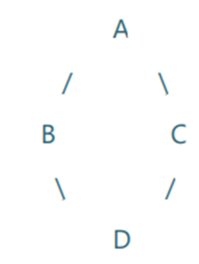

1. Interfaces also may contain public default methods with concrete default implementations – **True**
2. There are two types of exceptions in java: checked and unchecked (runtime) exceptions - **True**
3. _____ is a Java API that is used to connect and execute query to the database - **JDBC**
4. Which of these keywords is used to manually throw an exception? -  **Throw**
5. Which of the following is correct about Java 8 lambda expression? - **Both of the above**
6. What is not considered as a Design principle - **High cohesion**
7. What is TRUE about Interface? - **All of the above**
8. What are the major components of the JDBC? - **DriverManager, Driver, Connection, Statement, and ResultSet**
9. When a reference variable of a Parent class refers to the object of the Child class, then it is known as - **Upcasting**
10. Which of the following contains only unimplemented methods? - **Interface**
11. What is used to execute parameterized query? - **PreparedStatement interface**
12. What is true for lambda expression? - **Lambda can be created using list of parameters, arrow sign, and body of the method**
13. Which of these classes are the direct subclasses of the Throwable class? - **Error and Exception class**
14. Which of the following is false regarding lambda expressions - **it is not possible to return lambda expressions from methods**
15. Which of these keywords is not a part of exception handling? - **Thrown**
16. Which of the following is correct about ResultSet class of JDBC? - **All of the above**
17. What is not a property of Exception Handling - **Terminate a program when exception occurs**
18. What will be the correct option of the following Java code snippet? interface ICust {...} class RegularCustomer implements ICust {...} class OneTimeCustomer implements ICust {...} - **OneTimeCustomer can be replaced with RegularCustomer**
19. Which of the following is not considered as good practice - **name methods using camel style**
20. What kind of exception appears when compiler will try to divide by 0? - **Arithmetic**
21. Using what kind of object you can execute sql commands? - **Statement**
22. What does Liskov substitution principle specify? - **parent class can be substituted by child class**
23. Which principle is broken in the following case: In class “Order you create methods to save order, to place the order in database and notification confirming the order - **SRP**
24. Which of the following is not correct property of exceptions - **Exception handling does not help to terminate program gracefully**
25. Which of the following are checked exceptions? - **NullPointerException**
26. Which of the design principles is best described by following statement: You need to develop programs in such a manner that program be autonomous and connected through abstraction (interfaces) - **DIP**
27. Which methods you can use to process the results of Result Set - **getString, getInt, next**
28. Which of the following method is used to perform DML (Data Manipulation Language) statements in JDBC? - **executeUpdate()**
29. Which symbol helps to dynamically pass parameters in PreparedStatement? - **Question mark**
30. Using which return type in methods you can return several values? - **Array List**
31. Which of the following is not an exception? - **ErrorException**
32. Which of the following holds data retrieved from a database after you execute an SQL query using Statement…. - **ResultSet**
33. Which of these keywords must be used to monitor for exceptions? - **Try**
34. What is not true for JDBC - **It can be found in special java.postgresql package**
35. In case of the following example, the result of the code will be:Dog d = null;System.out.println(d instanceof Dog) - **False**
36. In case of the following example,what will be result of the code, if class Dog extends class Animal: Dog d = new Dog();//syntax of upcasting System.out.println(d instanceof Animal) - **False**
37. L in SOLID stands for - **Liskov's substitution principle**
38. Interface Segregation Principle stands for - **Object shouldn't be forced to implement an interface that it doesn't use**
39. Dependency Inversion Principle stands that - **Code should depend on abstraction**
40. The statement: "Reflection exists only in java programming language" is - **True**
41. The Java feature, "write once, run anywhere", is termed as - **Platform independent**
42. It is possible to invoke methods at runtime irrespective of the access specifier (private/public) with the use of some API - **True**
43. Exceptions are mainly caused by the environment in which an application is running. For example, OutOfMemoryException happens when Java runs out of memory - **False**
44. JDBC is a Java API that is used to connect and execute query to the database - **True**
45. Parameterized queries can be executed by? - **PreparedStatement**
46. Parameterized queries in JDBC can be executed by? - **PreparedStatement**
47. Select the package in which JDBC classes are defined? - **sql**
48. Select the packages in which JDBC classes are defined? - **sql and javax.sql**
49. A class should have only one reason to change is definition of which principle? - **SRP**
50. Ability to change behaviour of the class without making change in class itself is property of which design principle? - **OCP**
51. Class Circle is subclass of Shape, class Shape has method isFilled() that checks if shape is filled or not. If you override method isFilled() in class Circle and you will throw exception when radius of the circle is less than or equal to 0 which design principle you are breaking? - **LSP**
52. Class Employee has method salary(). If I create another class EmployeeSalaryUpdate that extends from Employee and will override salary() method to add bonuses for overtime work which principle I will follow? - **OCP**
53. Consider some class HashMap<K,V>, what is correct way to instantiate object of this class? - **HashMap&amp;lt;Integer,String&amp;gt; map = new HashMap&amp;lt;Integer,String&amp;gt;();**
54. Entities should be open for extension, but closed to modifications is definition of which principle? -  **OCP**
55. Fill the gaps: Block finally is executed ______ try-catch block ______ - **before, only when there is no exception**
56. Generic types can be placeholders for - **Reference data types**
57. How we call problems that rises when we are running programs? - **Exceptions**
58. How you can display the exception message to the console? - **In catch block using instance of Exception class print the instance in the body of the block**
59. In following lambda expression: "Subtraction sub1 = (x, y) -> x-y;" how we can trigger it? Assume interface Subtraction has single method "int subtract(int f, int z)" - **sub1.subtract(10,5);**
60. In JDBC you need to use ResultSet... - **to get all values from a table and store them**
61. In main method: "public static void main(String[] args)", what is return type? - **void**
62. Are ResultSets updateable? - **Yes, but only if we indicate a concurrency strategy when executing the statement, and if the driver and database support this option.**
63. Can we keep other statements in between try, catch and finally blocks? - **No**
64. Can we override a super class method which is throwing an unchecked exception with checked exception in the sub class? - **No**
65. Can we throw an exception manually? - **Yes**
66. Can we write only try blocks without catch blocks? - **Yes, but it is required to add finally block**
67. Does finally block get executed If either try or catch blocks are returning the control? - **Yes**
68. Exception generated in try block is caught in ______ block - **catch**
69. Exceptions are mainly caused by the application itself. For example, NullPointerException occurs when an application tries to access null object - **True**
70. What is false regarding statements in JDBC? - **Statement can accept parameters at runtime.**
71. From which of these lines we understand that the class Response was created using the Builder Pattern? - B(?)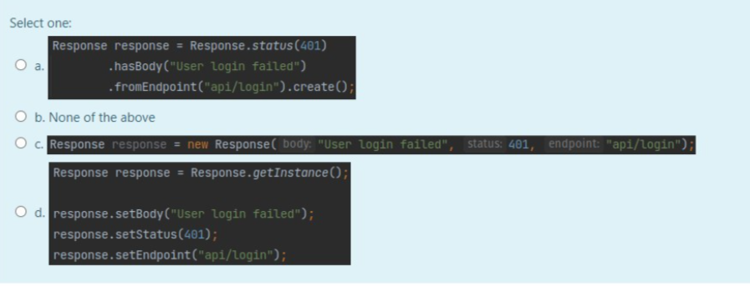
72. Which lambda expression is correct for following interface? - **A**

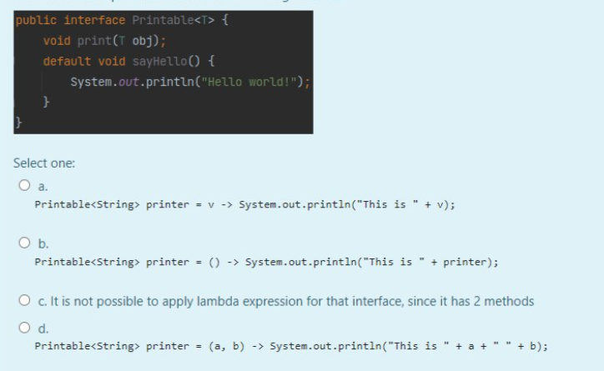

1. What are return types of following methods in the given class ProductBuilder, assuming that it is helper class for creating an object of Product class, according to Builder Pattern? - **B**

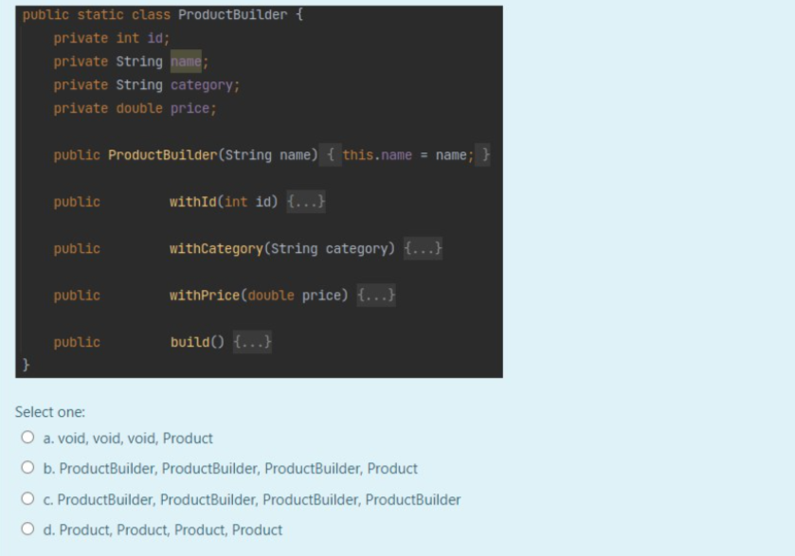

1. Which of these follows Singleton pattern? - **C**

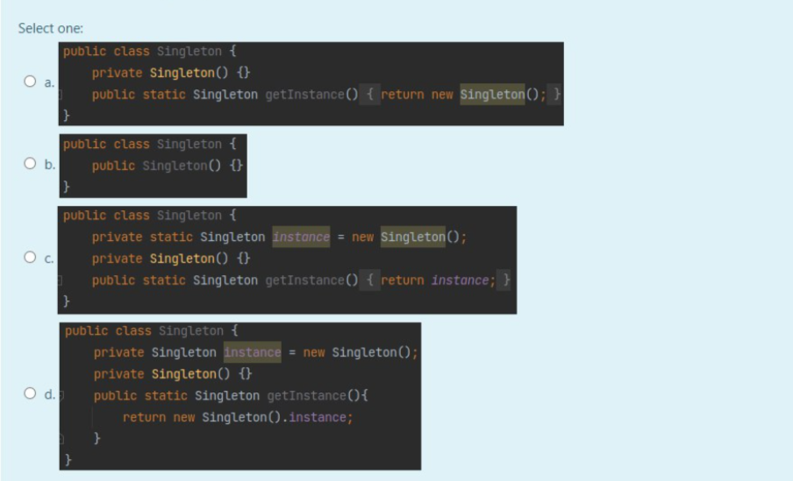

1. What is the output of following snippet, assuming that class User has private fields like: id, name and surname? - **B**

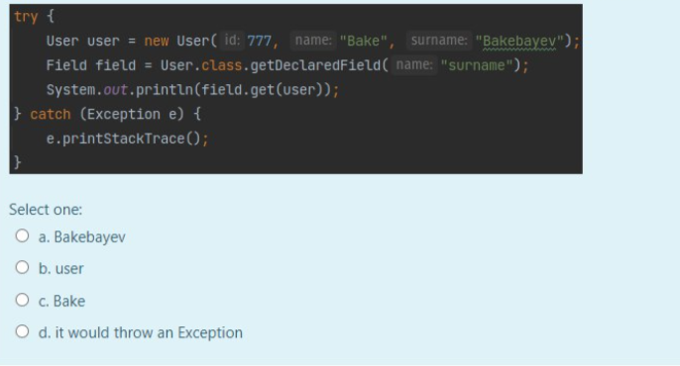

1. What is the output of following snippet, assuming that class User has private fields like: id, name and surname? - **D**

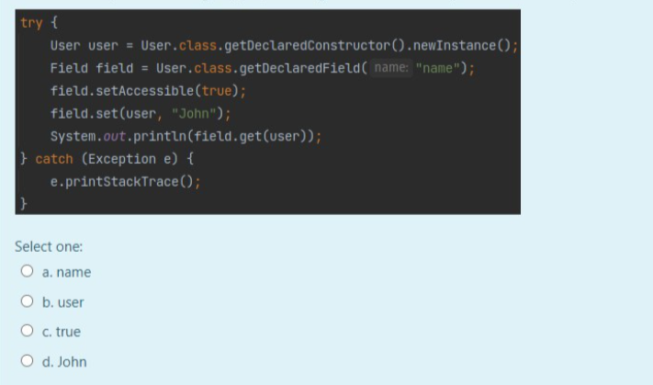

1. What is the proper way to change this class so that it would work not only with integers? - **B**

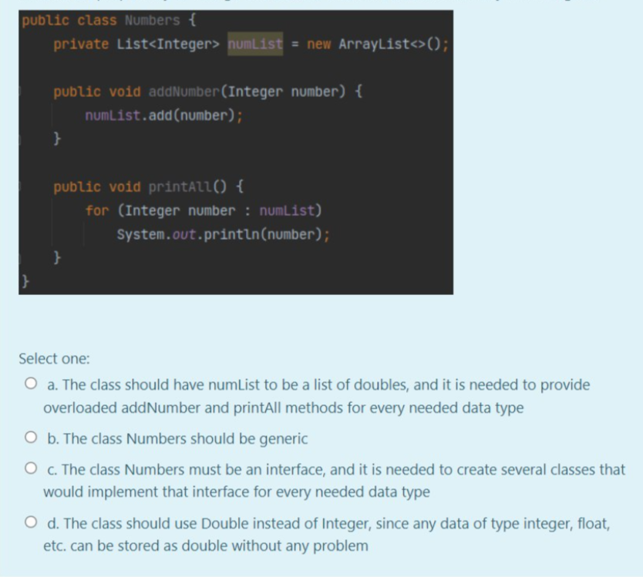

1. Why we need to handle exceptions? - **To prevent abnormal termination of program**
2. Which is the universal exception handler class? - **Exceptions**
3. There can be a try block without catch block but vice versa is not possible - **True**
4. How many catch blocks can a single try block can have? - **As many as required**
5. Which of the following is FALSE about abstract classes in Java - **A class can inherit from multiple abstract classes**
6. Which of the following is true about interfaces in java - **1, 3 and 4**
7. Predict the output of the following program - **Compilation Error**

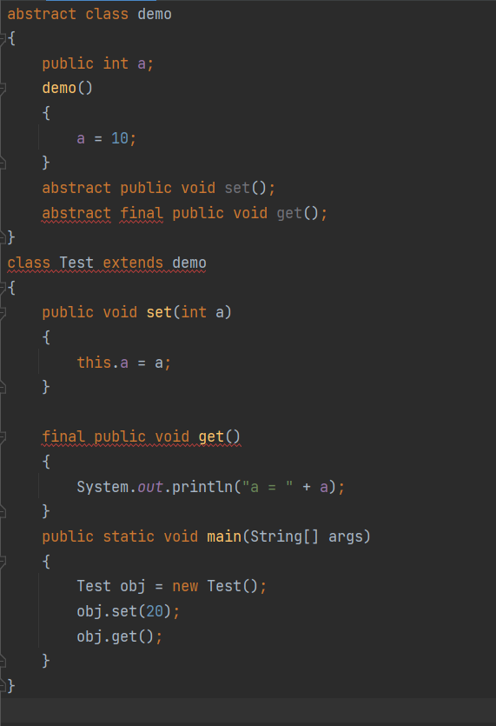

1. Output of following Java program - **20**

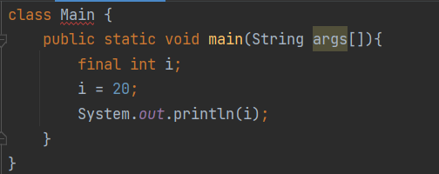

1. Output of following Java program - **Compiler error**

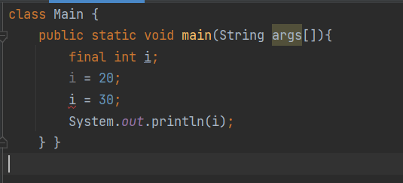

1. What will be the output of the following code? - **Compiler error**

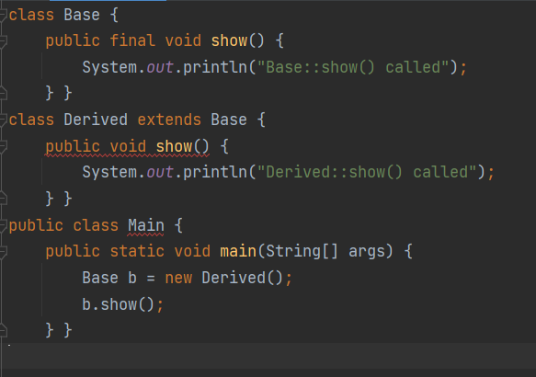

1. Which polymorphism behavior do you see in below class? - **Method Overloading**

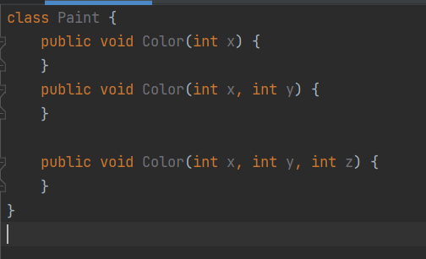

1. Which feature comes under compile time polymorphism? - **Both a and b**
2. What constitutes Bad Software Design? - **Immobility, Rigidity, Fragility**
3. Abstract class can have constructors and static methods? - True
4. What will be the output of the program? - **Compilation Fails**

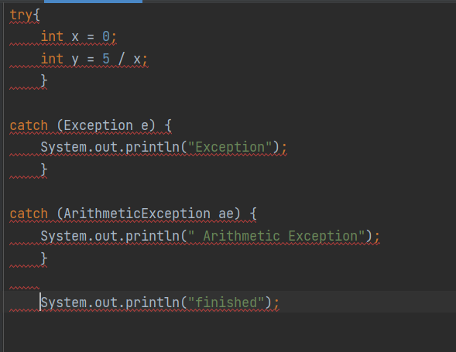

1. What will be the output of the program? - **BCD**

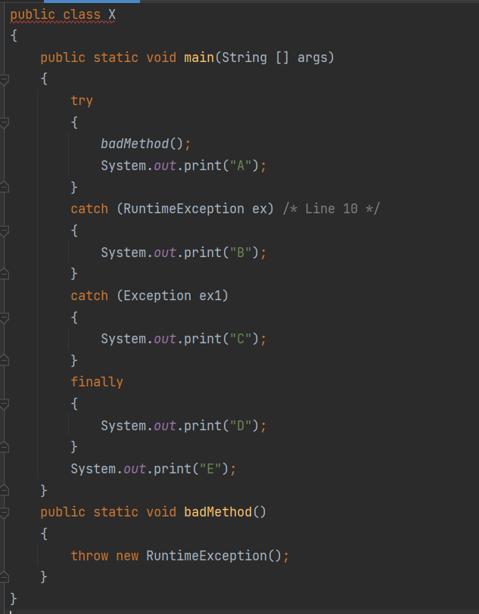

1. What will be the output of the program? - **ACD**

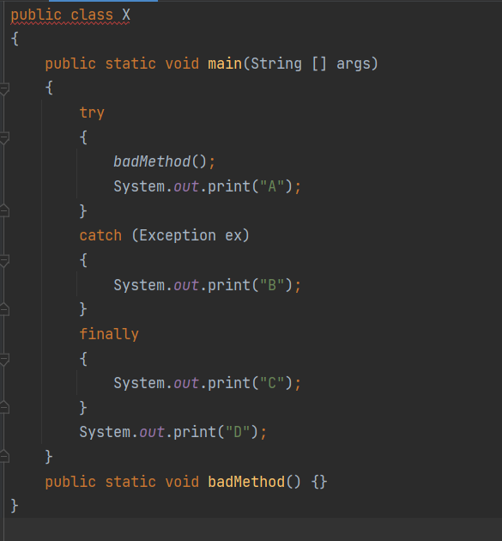

1. What concepts come under Polymorphism in java? - **All of the mentioned**
2. If A is a class.....B and C are interfaces, what is the proper signature for class A to extend interfaces B and C? - **public class A implements B, C{}**
3. A class that cannot be subclassed is called a ________ - **Final class**
4. In the example code fragment shown below:public abstract class Test { // . . . more class code - **No object of type Test can ever be created**
5. In Object-Oriented Programming, public, private & protected are - **Access Modifiers**
6. How do you call a group of related methods with empty bodies? - **interface**
7. This class cannot be used to instantiate objects - **Abstract class**
8. What is the correct sequence to create a database connection?i.Import JDBC packages.ii. Establish the connection.iii. Define the connection URL.iv. Execute a query.v. Create a statement object.vi. Close the resultset and statement objects.vii. Process the resultset.viii. Close the connection - **i, iii, ii, v, iv, vii, vi, viii**
9. What will be the output of the following Java code? - **Compilation failure**
10. What will be the correct option of the following Java code snippet? interface ICust {...} class RegularCustomer implements ICust {...} class OneTimeCustomer implements ICust {...} - **ICust can be replaced with RegularCustomer**
11. How many errors in the code below? - **4**
12. How many errors in the code below? - **difference in “PRIVATE FLOAT totalSales;” and “PRIVATE totalSales;”**